COM535 Cyber Security Lab

Instructions

- Visit https://www.hacksplaining.com/lessons

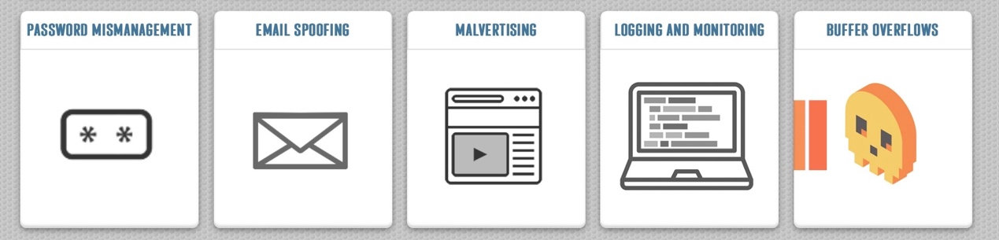

- Complete the five vulnerability lessons which are Password Mismanagement, Email Spoofing, Malvertising, Logging & Monitoring and Buffer Overflows.

- Visit https://tryhackme.com/

Endpoint Security Monitoring

- Complete Into to Endpoint Security https://tryhackme.com/jr/introtoendpointsecurity

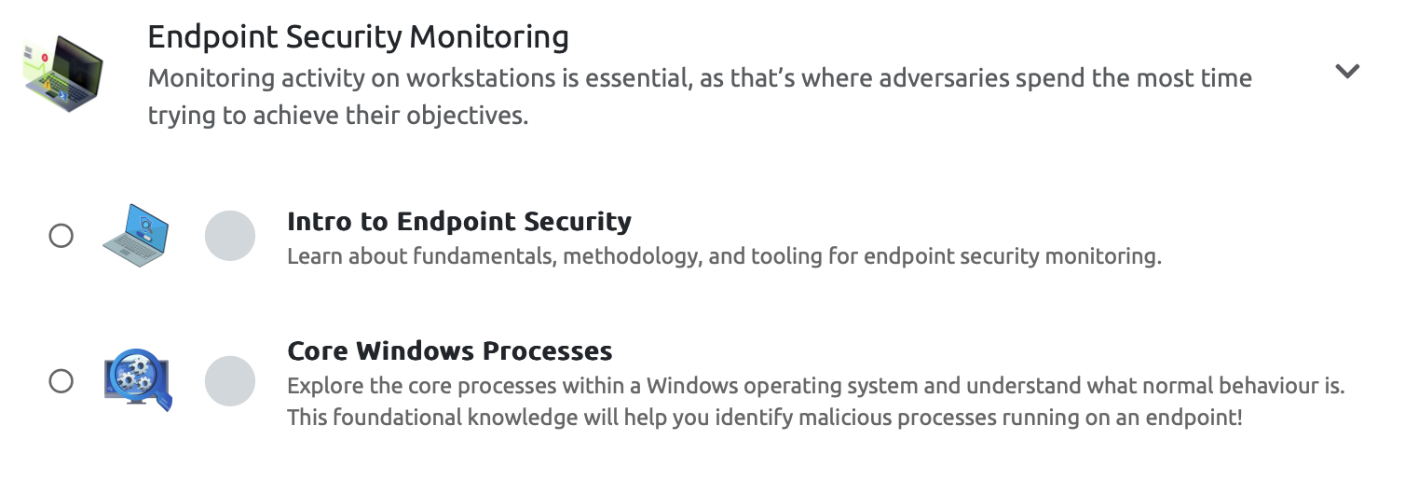

Help Video: https://youtu.be/3D7urDLThJQ

Security Information & Event Management

- Complete Intro to SIEM
https://tryhackme.com/room/introtosiem

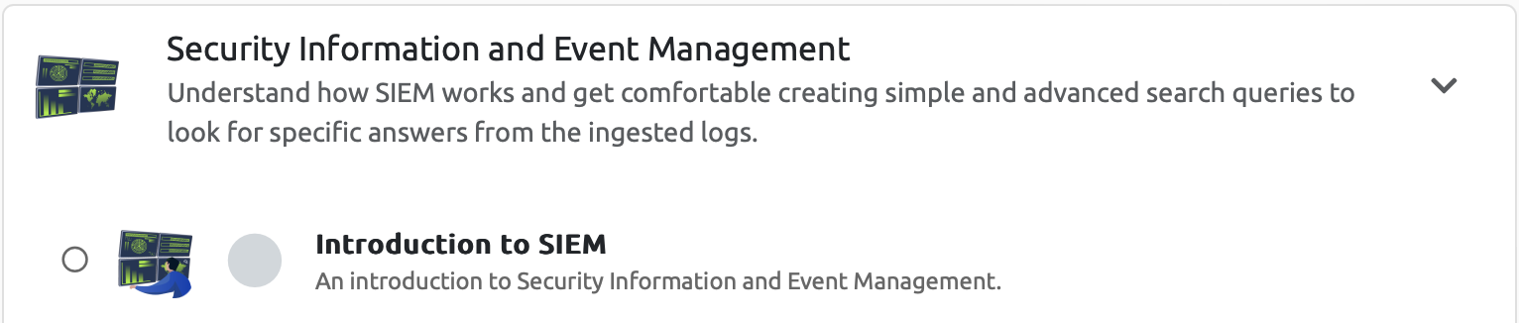

Help video: https://youtu.be/zvFhIu94Yfs

